Client Name___________________________________________________________________ Today’s Date______________________
Occupation_________________________________________________________ Birthdate_________________________________
- What are you hoping to gain from massage?

- Have you ever had a professional massage/bodywork? Yes_____ No_____
If so, what kind(s)?

- Are you presently under a doctor’s or therapist’s care? Yes_____ No_____

- Please list current symptoms____________________________________________________________________________________

- Please list any medications you are taking____________________________________________________________________

What side effects, if any, do you experience?__________________________________________________________________

- Do you smoke? Yes_____ No_____
- Do you have any allergies? Yes_____ No_____

If so, to what? ______________________________________________________________________________________________________
- Do you wear contact lenses? Yes_____ No_____

- Are you pregnant? Yes_____ No_____ If so, what is your due date?__________________________________________

- What kind of exercise do you do regularly?___________________________________________________________________
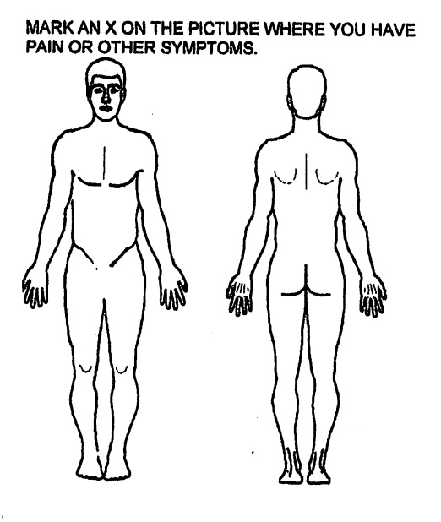
How often?____________________________________________________________________

Are you experiencing any pain today? Yes_____ No_____

If yes, how long have you had this pain?___________________________________________________
If yes, please mark the amount of pain sensation and
unpleasantness on the scales below:

Pain sensation: how much pain you feel physically in your body
0____________________________________________________10
No Pain Most Pain Possible

Pain unpleasantness: how much the pain in your body bothers you
0_____________________________________________________10
No Unpleasantness Most Possible Unpleasantness

Please check any of the following conditions which you currently have or have experienced in the past. Some may be contraindications for massage. Massage is not designed to treat the following conditions but information will help us to plan the session.

Systemic Infections
- Mononucleosis
- Flu
- Hepatitis
- Fever
- Other Virus________________________

Cardiovascular
- Varicose Veins
- Phlebitis
- Stroke
- Blood Clots
- Acute Inflammation
- Heart Attack
- Heart Disease
- High Blood Pressure
- Low Blood Pressure
- Other_____________________

Musculoskeletal
- Whiplash
- Low Back Pain
- Strain/Sprain
- Fracture
- Osteoporosis
- Scoliosis
- Arthritis
- Foot Pain
- Torn Ligaments/ Cartilage/Tendons
- Sports Injuries
- Other______________________
Neurological
- Sciatica
- Headaches
- Slipped disc
- Numbness/Weakness/ Coldness in Limbs
- Other_____________________

Skin Infections
- Eczema
- Burns
- Other_____________________

Endocrine
- Diabetes
- Hypoglycemia
- Other_____________________

Respiratory
- Emphysema
- Hay Fever
- Asthma
- Other_________________

Reproductive
- Menstrual Cramps
- PMS
- Prostatitis
- Other_____________________
Digestive
- Constipation
- Diarrhea
- Colitis
- Crohn’s Disease
- Other_____________________

Urinary
- UTIs
- Frequent Urination
- Difficult/Painful Urination

Psychiatric
- Mood Swings
- Sleep Disorders
- Exhaustion
- Depression
- Acute Anxiety
- Other_____________________

Cancer: Please describe
type and stage, with dates
Surgery: Please
describe with dates
Miscellaneous: Please describe
any other conditions (Include dates)

